Building a static website - Enchanted Threads Boutique

Gaurav Thapaliya

12202134

Introduction

Enchanted Threads Boutique is a boutique clothing store that has a wide range of clothing displays for people of all ages. It deals mostly with designer clothings. Here we are creating a static website for the business to promote it to the customers and let them browse through the catalog online.

Website Structure

The website is built using HTML5, CSS and JavaScript. There is no framework being used here and all the pages are structured manually.

The code contains two main folders – src and resources.

The src folder contains all the html files while the resources folder has media resources like images and videos and stylesheets. All of these are placed in their respective subfolders.

The index.html page serves as the home page of the website which has several sections and links to different pages. At the top and bottom of every page there is header and footer sections. The header section has the business logo, name and a navigation bar and the footer section has links to socials.

**Header**:

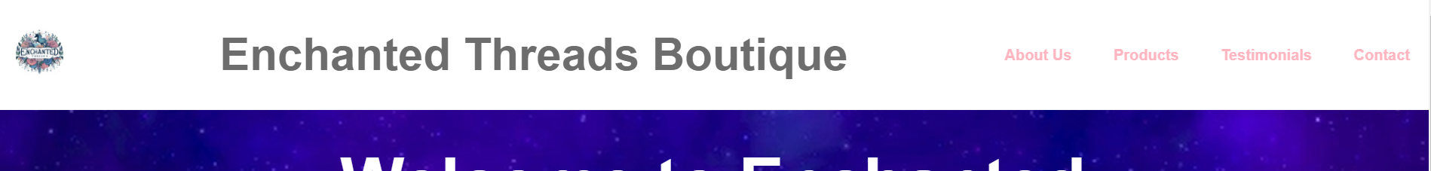

**Footer**:

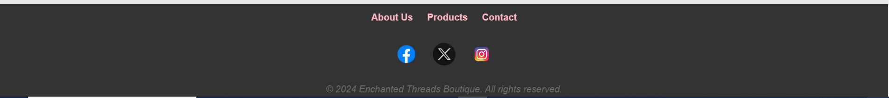

The other pages are: About Us, Products, Testimonials and Contact pages.

The form validation using JavaScript is done in the Contact page where a form is presented to the user to send messages to the business.

The Products page has interactive visual feature where clicking on the product image would enlarge the image and display it as an overlay.

Accessibility and Usability concerns

While designing any website, it is of utmost importance to focus on user experience. A website should be made such that it urges users to spend more time on the website while still finding it exciting and easy to use.

Here, I have made a consistent header throughout all the pages of the website so that the user doesn’t feel lost. The header has a navbar that has links to all main pages so that the user can access those pages from any page they are currently on.

The color combination is used consistently throughout the website by defining three main colors on the stylesheet and using them as per need.

Also, I have focused on accessibility for visually impaired users and have placed relevant alternative texts to every image so that the user can make use of text to speech and get an idea of what is being displayed on the screen.